

Question 1 - Documentation

Assessment 3 – Project



Table of Contents

1. What data structures are you using? 2

2. Where are you using hashing techniques? 2

3. What sorting algorithm are you using how this is different from selection and bubble sort? 2

4. What search technique are you using? 2

5. What third party libraries are you using? 2

6. Where can I find the documentation for this? 3

7. A mock-up of the GUI. 3

8. What source control are you using? 4

9. What are your coding standards you are enforcing? 4

10. What tests are you going to run? 4

Bibliography 5

Glossary of Term 5

# 1. What data structures are you using?

The data structures I am using are:

* LinkedList – This is a data structure where elements are not stored in contiguous locations.
* List – This defines a sequential set of elements which you can add, remove or update an element.
* Hashing – This designed to use a function called Hash function which is used to map a given value with a particular key for faster access to element.

# 2. Where are you using hashing techniques?

* Use it to login to Server Form
* Server Form, use it to create users and test user login account
* Client Form, use it to login it to access certain buttons

# 3. What sorting algorithm are you using how this is different from selection and bubble sort?

I am using Bubble Sort as my sorting algorithm. Bubble sort operates by comparing each item or element with the item next to it and swapping them if needed whereas selection sort arrange an array via finding its largest element and exchanging it with the last element, and repeat the following process on the sub-arrays till the whole list is sorted and Insertion sort is based on the idea that one element from the input elements is consumed in each iteration.

In both selection and bubble sort, the comparison is always among the unsorted elements and it swap the unsorted elements to create sorted list whereas in insertion sort, the comparison is between the unsorted and sorted elements and it shift the unsorted elements to create the sorted list.

# 4. What search technique are you using?

I am using Binary Search technique. This algorithm is fast search algorithm with run-time complexity of O (log n). It works based on the principle of divide and conquer. For this algorithm to works, data collection should be sorted.

# 5. What third party libraries are you using?

The third party libraries I am going to use is LumenWorksCsvReader. This library provides fast parsing and reading of CSV files.

Below are the URL for this third-party library:

<https://www.nuget.org/packages/LumenWorksCsvReader/>

# 6. Where can I find the documentation for this?

You can find a documentation of this project at GitHub. I will be implementing Version Control when I upload my documentation to GitHub because this helps me to keep track the records changes to a file or set of files over time.

Link: <https://github.com/DanielHee59/Programming-3---Project>

# 7. A mock-up of the GUI.

This is just an early prototype version of GUI. In my application, I will be including a Main Page, Server Page, Client Page, CSV Reader and Music Player to my GUI.

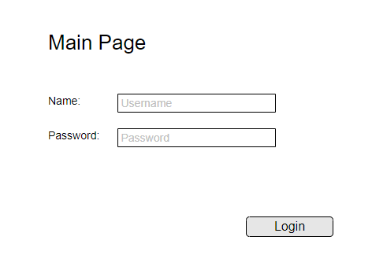

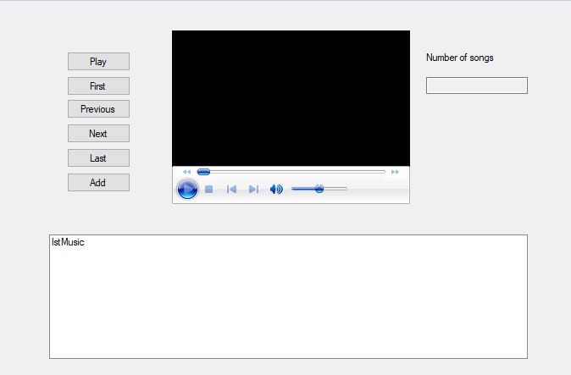

# 8. What source control are you using?

I am using GitHub as my source control. GitHub is a web-based hosting service for developers to share their projects with others. You can do contributing to an open source project and you can upload your documentation on GitHub.

# 9. What are your coding standards you are enforcing?

* Layout Conventions
* Commenting Conventions
* Try-Catch and using Statements in Exception Handling

# 10. What tests are you going to run?

* Debugging
* Login in to Server
* Create a user from Server Side
* Login from Client Side
* Display CSV file using third party libraries
* Sort Alphabetically
* Search within the list

# Bibliography

*Insertion Sort*. (n.d.). Retrieved from Hackerearth: https://www.hackerearth.com/practice/algorithms/sorting/insertion-sort/tutorial/

Millado, E. (2016, October 28). *Algorithms for Beginners — Bubble Sort, Insertion Sort, Merge Sort*. Retrieved from Medium Corporation: https://medium.com/yay-its-erica/algorithms-for-beginners-bubble-sort-insertion-sort-merge-sort-29bd5506cc48

# Glossary of Term

**Comma-Separated Values (CSV)** – This allows data to be saved in a tabular format.

**Uniform Resource Locator (URL)** - It is a reference to a web resource that specifies its location on a computer network and a mechanism for retrieving it.

**Graphic User Interface (GUI)** – This is a form of user interface that allows users to interact with electronic devices through graphical icons and audio indicator.